Press Information

February 15, 2017

**Philips Lighting launches new “click-to-fit” T5 LED tube for professional market**

*New Philips T5 LED tube offers first true 1:1 replacement with widest ballast compatibility for 1500mm T5 fluorescent bulbs*

**Eindhoven, the Netherlands –** Philips Lighting (Euronext Amsterdam ticker: LIGHT), a global leader in lighting, today announced the new [Philips T5 LED tube](http://www.lighting.philips.com/main/prof/lamps/led-lamps-and-systems/led-tubes/master-ledtube-instantfit-hf-t5) to the [Philips MASTER LEDtubes](http://www.lighting.philips.com/main/products/led-tube.html) portfolio. The energy-saving T5 LED tube offers high light output and quality, and the widest ballast compatibility, so that it is a simple “click-to-fit”. The Philips T5 LED tube comes in a small form factor, providing a high performance of 150 lumens per watt.

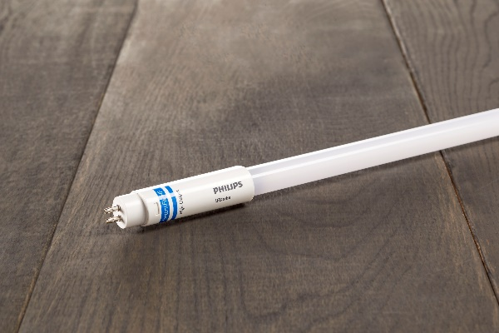**Easy to fit installation and safety**

Philips MASTER LEDtubes offer a 100% safe and easy installation with a simple lamp-for-lamp replacement. Using InstantFit technology, the T5 LED tube can fit straight into existing luminaires and requires no wire replacement. Electrically safe pins and the isolated driver make it easy to handle the tubes without the risk of shock. This will help installers to install quickly with precision, saving them time and money.

**Long-lasting quality**

The Philips T5 LED tube is made of polycarbonate to realize superior heat management over its lifetime. With a guaranteed lifetime of 50,000 hours the T5 LED tube outshines fluorescents with twice the lifetime and halves maintenance costs.

“While the average buying price of fluorescents might be less expensive, the total costs per year are more than double compared to Philips T5 LED tubes,” said Robert Boogard, Product Manager at Philips Lighting. “To ensure further quality, we’re pleased to extend our warranty on professional LED lamps to five years. With the widest LED tube portfolio on the market, we’re able to ensure lasting light fit for every application whether car parks or offices, to schools and warehouses.”

The new Philips T5 LED tube is now available in most European markets and comes in the following types:

* 1500mm HO 26W 830 T5 InstantFit
* 1500mm HO 26W 840 T5 InstantFit
* 1500mm HO 26W 865 T5 InstantFit

**For further information, please contact:**

**Philips Lighting, Global Media Relations**Bengi Silan Genc

Tel: +31 6 2544 1798  
E-mail: [bengi.genc@philips.com](mailto:Bengi.Genc@philips.com)

**About Philips Lighting**

Philips Lighting (Euronext Amsterdam ticker: LIGHT), a global leader in lighting products, systems and services, delivers innovations that unlock business value, providing rich user experiences that help improve lives. Serving professional and consumer markets, we lead the industry in leveraging the Internet of Things to transform homes, buildings and urban spaces. With 2016 sales of EUR 7.1 billion, we have approximately 34,000 employees in over 70 countries. News from Philips Lighting is located at <http://www.newsroom.lighting.philips.com>