Press Information

April 4, 2017

New research reveals outdoor lighting makes homes more attractive to buyers

- Around half (49%) of Europeans are more likely to purchase a home that has outdoor lighting, either at the front of the house or in the garden
- 76% of Spaniards are more likely to purchase a home which has outdoor lighting, versus only 36% of Britons
- Across Europe, 71% agree outdoor garden lighting adds to the overall atmosphere of a home

Eindhoven, The Netherlands – Philips Lighting (Euronext Amsterdam ticker: LIGHT), a global leader in lighting, has today released findings that reveal the impact outdoor lighting has on ‘curb-appeal’ or the desirability of a home. Outdoor lighting is a key consideration when buying a home for nearly half of Europeans (45%) – beating the type of windows, roof or paintwork of a house, as a consideration. While one third of all Europeans agree that outdoor lighting has a significant impact on the appeal of a home.

Setting the right scene
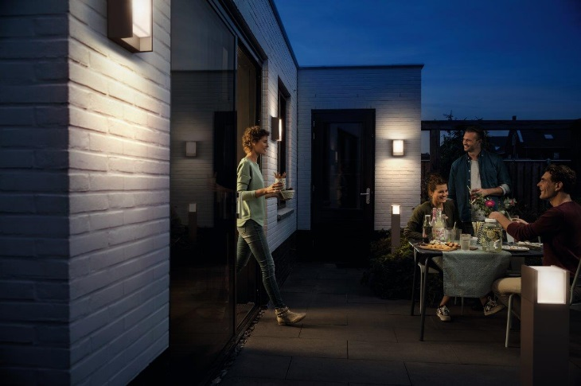
The study of over 7,000 adults across five European countries – Germany, UK, France, the Netherlands and Spain – also emphasized the importance of lighting up your outdoor spaces in order to create the right mood, inside and outside the home. Two thirds (65%) of those surveyed agree that outdoor lighting in the garden adds to the overall atmosphere of a home. The Spanish place the most value on outdoor lighting for setting the perfect scene, with over 80% agreeing outdoor lighting adds to a home’s ambiance. While in the North of Europe, many believe the opposite, with nearly half (43%) of Britons disagreeing that outdoor lighting adds to creating the right mood.

“Outdoor lighting can often be overlooked but it is key to showing off your home the way it was meant to be seen at nighttime, and can be used to highlight the most attractive aspects, whether you’re viewing from inside the home, or out. Purchasing outdoor lights which use LED modules or LED lightbulbs, such as Philips LED outdoor lighting, is also a great value-add for the property owner, with the short-term investment paying dividends in the long-run,” commented Bianca Heiszwolf, leader of Philips Lighting Home Luminaires.

From scenes to safety
Outdoor lighting around a home is also proven to create a sense of security. The research found that 73% of Europeans feel a home is safer to approach with lighting in the front garden. The older generation places the most emphasis on outdoor lighting for a sense of safety, versus the younger generations – 77% of those older than 55 years old agree outdoor lighting makes you feel safer, versus only 69% of those under 35 years old.

Increasing the value of a home
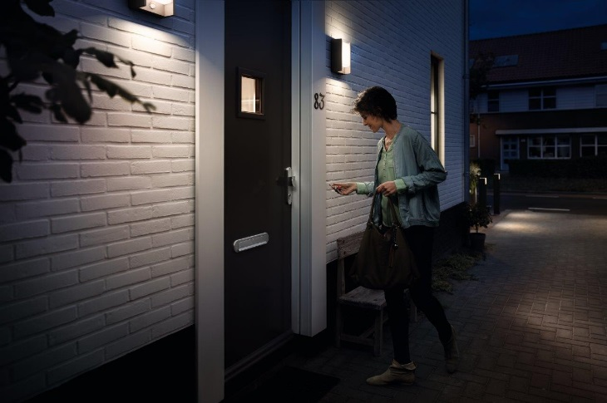
All surveyed countries agreed a home’s fabled ‘curb-appeal’ improves greatly with outdoor lighting; around half of respondents are more likely to purchase a home that has outdoor lighting either at the front of the house (51%) or in the garden (48%). It is also a stronger consideration for younger generations – with over half (53%) of 18-35 years olds stating outdoor lighting would make them more likely to buy a home, versus only 46% of those older than 45 years old.

When it comes to purchase power, the Spanish again responded more favorably than other Europeans, with around three-quarters of adults saying they are more likely to buy a home with outdoor lighting featured in the front (77%) or in the garden (74%). Conversely, the UK sits at the other end of the scale, with less than two in five (36%) respondents saying they’re more likely to purchase a home with outdoor lighting.

Housing expert, Sam Mitchell of Rightmove, the UK’s largest property portal, commented: “First impressions are everything on viewings, which is why outdoor lighting could be worth considering, as it can be used to help change the look of the exterior of a home, especially if you are conducting viewings in the evening. There are also many other factors to think about when preparing your home to sell it; such as decluttering, spending a bit of money giving the place a lick of paint, or considering larger works like refurbishing the kitchen or extending the property.”

LED lighting perfect for any outdoor space
For those looking to improve their ‘curb-appeal’, Philips LED outdoor lights come in a variety of shapes, sizes and look and feel. The Philips Hoverfly outdoor wall light is perfect for those who are looking for industrial chic. While the Philips AfterGlow LED outdoor wall light is a great way to emphasize a feature wall or plant. Alternatively for bold, stand-out lights, the Philips Shadow LED outdoor wall light is the perfect choice. All these lights launch from April 1st.

Notes to editors
*Source: All figures, unless otherwise stated, are from YouGov Plc. Fieldwork was undertaken between 28th December 2016 - 11th January 2017 in the UK (2,116 sample size), France (1,014 sample size), Germany (2,048 sample size), Spain (1,000 sample size) and the Netherlands (1,000 sample size). The surveys were carried out online. The figures have been weighted for each country and are representative of all adults (aged 18+).

For further information, please contact:

Philips Lighting Media Relations
Bengi Silan Genc
Tel: +31 6 2544 1798
E-mail: bengi.genc@philips.com

About Philips Lighting
Philips Lighting (Euronext Amsterdam ticker: LIGHT), a global leader in lighting products, systems and services, delivers innovations that unlock business value, providing rich user experiences that help improve lives. Serving professional and consumer markets, we lead the industry in leveraging the Internet of Things to transform homes, buildings and urban spaces. With 2016 sales of EUR 7.1 billion, we have approximately 34,000 employees in over 70 countries. News from Philips Lighting is located at http://www.newsroom.lighting.philips.com

