Press Information

January 12, 2017

If it’s time to go to the gym, then have my Philips Hue lights flash red

- IFTTT officially joins the Friends of Hue partner program
- Partnership kicks off with a global competition

Eindhoven, the Netherlands – Philips Lighting (Euronext Amsterdam ticker: LIGHT), a global leader in lighting, today announced that smart home connection platform, IFTTT, became an official partner in the Friends of Hue program. This certifies the seamless integration of IFTTT software working with Philips Hue.

What is IFTTT?
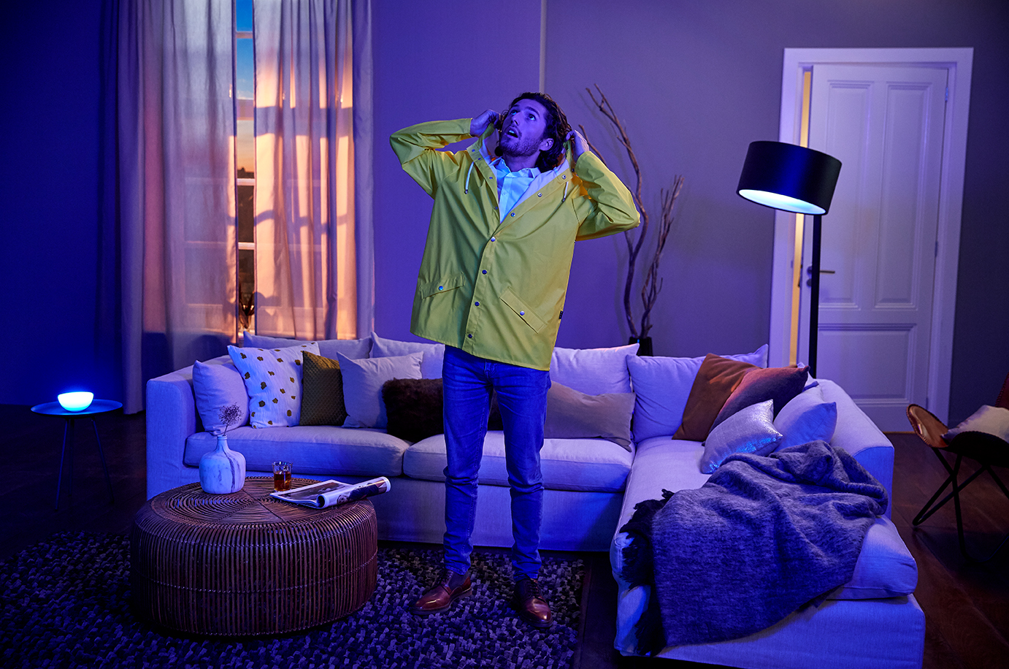
IFTTT brings together the apps you use every day, from weather notifications to managing contacts and connects them via Applets — enabling you to create new experiences. Integrated with Philips Hue since 2013, the IFTTT Applets allow you to connect over 400 services to control and enhance your smart home experience. For example, you can turn on Applets that trigger your Philips Hue lights to change color when the International Space Station passes over your home, flash your team’s colors when they score, or remind you to bring an umbrella by turning your lights blue when rain is forecasted.

Friends of Hue Partner and Competition
Today IFTTT became an official Friends of Hue partner, allowing the platform to be fully integrated with Philips Hue. To celebrate this partnership, Philips Lighting and IFTTT are launching a global competition to come up with the coolest, most creative Applet for Philips Hue.

The challenge is to come up with an idea for an Applet that will help you realize your recently declared New Year’s resolutions. Simply post the Applet idea on the Philips Hue Facebook page or use #HueOnIFTTT on Twitter to enter. Entries will be judged by a panel from Philips Lighting and IFTTT and the person with the most original and inventive Applet will win EUR 2,000 worth of Philips Hue products to equip their home. So get creative!

Philips Hue - IFTTT is now a Friends of Hue partner video

Linden Tibbets, CEO of IFTTT, says: “We’re excited to join the Friends of Hue program and solidify our partnership with Philips. They’re one of the most popular and innovative services on the platform. They’re a pioneer when it comes to smart home experiences, and we’re proud to be a part of that legacy. We look forward to the opportunities that lie ahead.”
George Yianni, Head of Technology Home Systems at Philips Lighting, adds: “IFTTT is one of the most popular integrations we have with Philips Hue, and we love the limitless possibilities it gives our customers to express themselves through light. With the competition, we want to take this to the next level and highlight how Philips Hue and IFTTT users can help them to reach their New Year’s goals.”

How is Philips Hue currently working with IFTTT? Have a look at the most popular Philips Hue Applets: https://ifttt.com/hue.

Notes to editors

About Philips Hue
Philips Hue is the world’s leading connected lighting system for the home. It comprises bulbs, strips, spots, lamps and controls. Through a vibrant developer program there are more than 600 third-party apps for Philips Hue. The system is transforming how light is used in and around the home to stimulate your senses, light your moments and helps to provide peace of mind when away from home.

From the launch of Philips Hue in October 2012, Philips Lighting has encouraged other companies to develop devices, apps and systems that interoperate with the system. From third-party apps and wearable technology, to internet services and connected home products; Philips Hue goes beyond illumination to provide more than just light - to deliver new experiences where the only limit is your imagination. For more information, please visit www.meethue.com

About the Friends of Hue partnership program
The Friends of Hue partnership program was announced to make sure that partner devices, systems and apps connected to the Philips Hue system work seamlessly. For partners, Philips Hue make its full API available to make it easy for them to integrate, while it tests and verifies the products and applications to ensure a seamless experience.

-ENDS-

For further information about Philips Lighting, please contact:
Philips Lighting global communications:
Paula den Dunnen
E-mail: paula.den.dunnen@philips.com

For further information about IFTTT, please contact:
Anne Mercogliano
E-mail: press@ifttt.com

About Philips Lighting
Philips Lighting (Euronext Amsterdam ticker: LIGHT), a global leader in lighting products, systems and services, delivers innovations that unlock business value, providing rich user experiences that help improve lives. Serving professional and consumer markets, we lead the industry in leveraging the Internet of Things to transform homes, buildings and urban spaces. With 2015 sales of EUR 7.5 billion, we have approximately 36,000 employees in over 70 countries. News from Philips Lighting is located at http://www.newsroom.lighting.philips.com

About IFTTT
IFTTT empowers people to make connections between the many services and devices they use every day. We connect over 400 apps, services, and devices including Facebook, Twitter, Philips Hue, Dropbox, Google, Nest, Fitbit, BMW, and Slack with Applets. Applets are new experiences that you can turn on with a single switch. IFTTT users rely on the platform to control their world in ways both large and small, from automating simple tasks to transforming how they experience and manage homes and habits. We believe creative control of the services we use should be intuitive and accessible to everyone. Founded in 2010, IFTTT has raised $39 million in funding from top-tier investors including Norwest Venture Partners, Andreessen Horowitz, NEA, Lerer Hippeau Ventures, and SV Angel.

