Press Information

March 28, 2017

From backyard BBQ to park-side picnic – enjoy long outdoor evenings with the new Philips Abelia LED lantern

- Portable Philips Abelia LED lantern is fully dimmable with candlelight effect
- Practical but ambient lighting for those with limited or no outdoor space - study by European Environment Agency finds more Europeans choosing to live in urban areas

Eindhoven, Netherlands – Philips Lighting (Euronext Amsterdam ticker: LIGHT), a global leader in lighting, has today launched the new Philips Abelia LED lantern, a portable light which provides an ambient, dimmable, warm white light and can also flicker to replicate candlelight. The launch comes when consumers are increasingly looking for versatile outdoor lighting options, especially within urban places, where space is at a premium. The lantern is dimmable, meaning you can set the right mood for a relaxing evening, romantic date, family gathering, or entertaining with friends – wherever you choose.

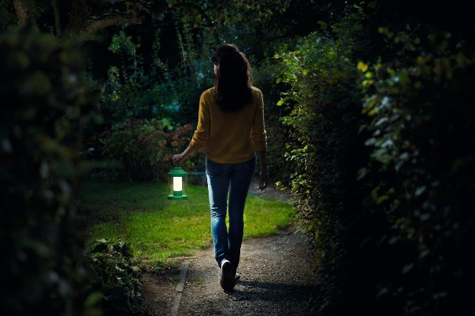
Research by the European Environment Agency found that around 75% of the European population live in urban areas¹. That rate is expected to rise over the coming years. By 2020, the United Nations Population Division predicts urban dwellers will account for 91% of the UK population, 86% in the Netherlands, 80% in Germany, 82% in France, and 98% of those in Belgium². The new Philips Abelia LED lantern is perfect for any urban space. For example, it can turn a rug in the park, on a warm summer night, into a light filled outdoor space to entertain in.

Damien Vever, Product Manager at Philips Lighting Home Luminaires, commented: “We believe that your outdoor space is an extension to your home – a place to cherish, keep safe and enjoy throughout the year. Our new outdoor lantern is designed with both function and ambiance in mind. Its portability means you can take it anywhere.”

Using an integrated Philips LED module, the lantern provides high quality light that’s dimmable by pressing and holding a button. The candlelight effect can be turned on or off depending on the moment you want to create. Conveniently charged by USB and with a selection of colors, including Black, White, Vivid Red, Vivid Green and Pastel Green, you can choose your favorite shade to match your outdoor space. Made from high-quality synthetic material, the lantern is built to survive even the harshest conditions of the great outdoors. To find out more about the Philips Abelia LED lantern, visit http://www.philips.co.uk/c-p/1736032P0/mygarden-table-lamp .

Tips from landscaping design expert, Matthew Wilson

Even the smallest outdoor spaces can benefit from lighting. Matthew Wilson, award-winning garden and landscape designer, shares his tips for illuminating smaller urban plots like terraces or concrete yards:

- Lanterns and string lights are perfect for adding fun lighting to your space. You don't want these blasting tons of bright light (that's what your overhead lighting above does when you need it). These are here to softly illuminate your whole outdoor area when you are entertaining or enjoying it solo.
- If you plan on having dinner parties outdoors, think about table top lights. Mason jars with tea lights, table-top lanterns, outdoor lamps all work well. You want to think about the sort of task lighting you'll need for the activities your outdoor area will be hosting.
- Consider path-finding lights. Dark yards and walkways can be a danger outdoors, especially for guests who may be unfamiliar with your home. So make the paths to and from your outdoor area clear, clean and well-lit.

- Source: European Environment Agency, “Urban environment” research, 2011. http://www.eea.europa.eu/themes/urban/intro
- Source: United Nations Population Division, “Population, Health and Human Well-being -- Urban and Rural Areas: Urban population as a percent of total population”, 2005. https://docs.google.com/spreadsheets/d/1CN5n085EWsxIKnJBvgGiGFZHtfl-WUCeGyaLehEPI0Q/edit#gid=0

For further information, please contact:

Philips Lighting Media Relations
Bengi Silan Genc
Tel: +31 6 2544 1798
E-mail: bengi.genc@philips.com

About Philips Lighting
Philips Lighting (Euronext Amsterdam ticker: LIGHT), a global leader in lighting products, systems and services, delivers innovations that unlock business value, providing rich user experiences that help improve lives. Serving professional and consumer markets, we lead the industry in leveraging the Internet of Things to transform homes, buildings and urban spaces. With 2016 sales of EUR 7.1 billion, we have approximately 34,000 employees in over 70 countries. News from Philips Lighting is located at http://www.newsroom.lighting.philips.com

