Press Information

September 22, 2016

Warsaw Spire inspires the Polish capital with bright new LED lighting

Over 88,000 Philips LED light points installed at the largest office complex and the second tallest building in Poland

Warsaw, Poland - Philips Lighting, a global leader in lighting, illuminated the newly built Warsaw Spire, the second tallest skyscraper in Poland with a Philips’ architectural LED lighting system. With over 88,000 LED light points installed on the 220-meter tall skyscraper, it is the largest installation of Philips Color Kinetics technology in Central Eastern Europe.

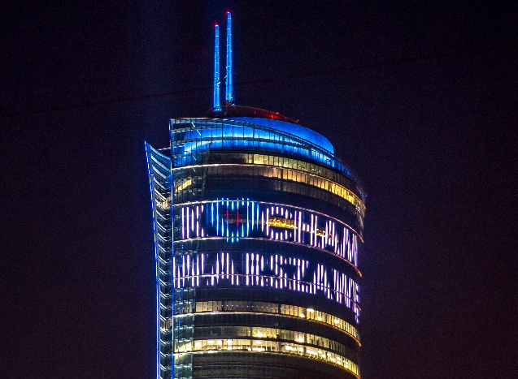
The recently opened Warsaw Spire complex, located in the business district in the heart of Warsaw, showcases the latest in architectural and lighting design trends. The entire façade is bathed in dynamic LED lighting and also incorporates two LED installations consisting of 80,000 individually controllable Philips iColor Flex light points. The LED installations are installed between the building’s façade panels at a height of 160 meters. The total size of both installations is over 5,500 m2, comparable to the size of a football field. The content displayed on the LED installations is visible within a radius of several kilometres from any place in Warsaw. As a welcoming gesture and surprise to the citizens of Warsaw the Warsaw Spire lit the skyline of Warsaw with a huge ‘I love Warsaw’ message during the construction of the skyscraper.
“The illumination on the Warsaw Spire is a part of our idea to open the buildings to the city and people. This is why we displayed the “I love Warsaw” motto on the façade and displayed other messages during events that are important for the city and its residents. For example, during the UEFA EURO 2016 football tournament we supported the Polish team and presented the results of the matches. This allows the building to come alive with the city’s highlights,” says Jeroen van der Toolen, Managing Director at Ghelamco, Central Eastern Europe.

“Philips Color Kinetics technology lights many of the world’s most recognized landmarks like the Empire State Building in New York, the London Eye and the Gateway of India. Our latest and largest installation in Warsaw is visible from kilometres away and attracts huge interest from citizens, contributing to the livelihood of the entire landscape.” says Bogdan Rogala, General Manager Philips Lighting in Central Eastern Europe.

The Warsaw Spire has a state-of-the-art LED lighting system that can be remotely controlled by a mobile device. The Philips LED lighting system is anticipated to be up to 75% more energy efficient compared to conventional lighting technologies.

Notes to editors
- The Warsaw Spire is the largest and tallest office complex in Poland and consists of three buildings: a 220-meter-high tower building with 49 stories and two 55-meter-high buildings. The total office space is 109.000 m^{2.}
- The size of the two LED installations on the façade is 71 meters in width and 39 meters in length, the largest of its kind in Poland. It contains 80,000 individual light points.
- The roof of the building is illuminated with Philips ColorGraze MX4 Powercore luminaires and the spires are lit with Philips ColorReach Powercore luminaires.
- The vertical and horizontal edges of the building with a total length of 1 km are illuminated with Philips iColor Flex nodes and a specially designed diffuser, providing a wide viewing angle, visible from many directions.
- The construction of Warsaw Spire took three years to complete, the official opening took place in May 2016.

For further information, please contact:
Philips Lighting Poland
Dorota Sławińska,
Tel: +48 605 342 517
E-mail: dorota.slawinska@philips.com

Philips Lighting Global
Anne-Marie Sleurink
Tel: +31 6 52 59 63 81
E-mail: anne-marie.sleurink@philips.com

About Philips Lighting
Philips Lighting (Euronext Amsterdam ticker: LIGHT), a global leader in lighting products, systems and services, delivers innovations that unlock business value, providing rich user experiences that help improve lives. Serving professional and consumer markets, we lead the industry in leveraging the Internet of Things to transform homes, buildings and urban spaces. With 2015 sales of EUR 7.5 billion, we have approximately 36,000 employees in over 70 countries. News from Philips Lighting is located at http://www.newsroom.lighting.philips.com

