Press Information

September 5, 2016

**Instant hit: Juventus impresses broadcasters and fans with new Philips pitch lighting system**

* ***Serie A champions Juventus is first club in Italy to adopt latest LED pitch lighting to meet stringent standards of international TV broadcasters***
* ***Lighting controlled by a touch panel to deliver amazing pre-match show***

**Monza, Italy –** Philips Lighting (Euronext Amsterdam ticker: LIGHT), a global leader in lighting and the Official Lighting Partner of Juventus, wowed fans in its stadium and watching on TV with a dazzling pre-match light show using its new Philips ArenaVision LED pitch lighting system. The new pitch lighting, which meets the latest standards of TV broadcasters and international football federations, was an instant hit with fans who expressed their delight on social media. Since its unveiling on August 20, at an evening match against Fiorentina the new lighting received a massive thumbs up with 43,000 Facebook likes, 37,500 shares and 2,700 enthusiastic comments and 3.89 million impressions on Twitter.

[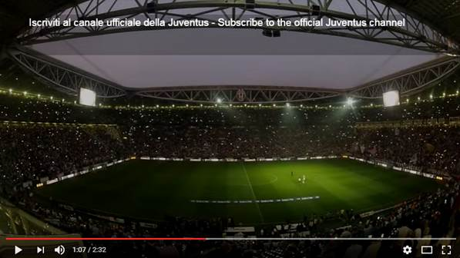](https://www.youtube.com/watch?v=BmpSXu987to)

*Offical video of the pre-match light show at the Juventus stadium*

Philips Lighting has a two year partnership with Juventus that will run till the end of 2016-2017 season to ‘light up’ the Juventus stadium. The iconic arena now boasts 396 Philips ArenaVision LED fixtures installed on the roof and on the technical walkways. Also, the hospitality areas, the Atrium of Honor and Club Partner Club Sivori, are refurbished with the latest lighting technology to create desired light setting and the right atmosphere. By upgrading the pitch lighting to the highest standards the Juventus stadium is able to elevate the entertainment experience to a whole new level during football matches and events.

”Our LED pitch lighting technology enhances the fan experience, allowing broadcasters to capture the tiniest gestures and details of every match,” says Paolo Recrosio, President Italy, Israel and Greece for Philips Lighting. “Partnering with Juventus we wanted to create the ultimate entertainment experience that allows fans to get excited and enjoy the full experience: from arrival at the stadium until after the game.”

The Philips ArenaVision pitch lighting system meets the needs of TV broadcasters and football federations which need high quality lighting to meet the needs of Ultra High Definition television and super slow motion action replays. In addition, it requires no warm up time and is flexible enough to allow illumination of specific parts of the pitch before a football match or as part of a light show.

For more than 60 years, Philips Lighting has been in sports lighting. It lights more than 65% of stadiums used in major international sporting events and 55% of the world’s main football stadiums use Philips Lighting technology.

####

**For further information, please contact:**

Philips Lighting Italy, Israel and Greece

Name: Corrado Massone

Tel: +39 34 89 00 82 38

E-mail: [corrado.massone@philips.com](mailto:corrado.massone@philips.com)

Philips Lighting

Name: Anne-Marie Sleurink

Tel: +31 6 52 59 63 81

E-mail: [Anne-Marie.Sleurink@philips.com](mailto:Anne-Marie.Sleurink@philips.com)

**About Philips Lighting**

Philips Lighting (Euronext Amsterdam ticker: LIGHT), a global leader in lighting products, systems and services, delivers innovations that unlock business value, providing rich user experiences that help improve lives. Serving professional and consumer markets, we lead the industry in leveraging the Internet of Things to transform homes, buildings and urban spaces. With 2015 sales of EUR 7.5 billion, we have approximately 36,000 employees in over 70 countries. News from Philips Lighting is located at [http://www.newsroom.lighting.philips.com](http://www.newsroom.lighting.philips.com/)