Media Backgrounder

October 21, 2016

Experience the future of light with Philips Lighting at Dutch Design Week
Philips Lighting presents two LED light installations at ‘Kazerne’ gallery and creative hub during Dutch Design Week 2016

Eindhoven, The Netherlands – Philips Lighting, a global leader in lighting, presents two creative LED lighting installations as part of Dutch Design Week which takes place in Eindhoven, The Netherlands from 22 October – 30 October 2016.

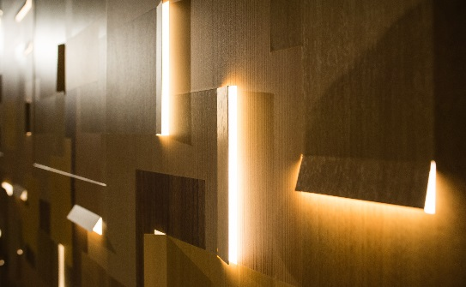
The “Light Forest” installation combines sculptural lighting effects directly into a uniquely detailed wall surface. Designed by Amsterdam- based design firm BCXSY using the Philips Luminous Patterns product system, the lighting installation explores how we will free ourselves of the traditional concepts of “light fixtures” and instead embed lighting directly into the walls and ceilings that surround us. The dynamic programming of the light patterns replicates the soothing experience of cascading patterns of light in a forest.

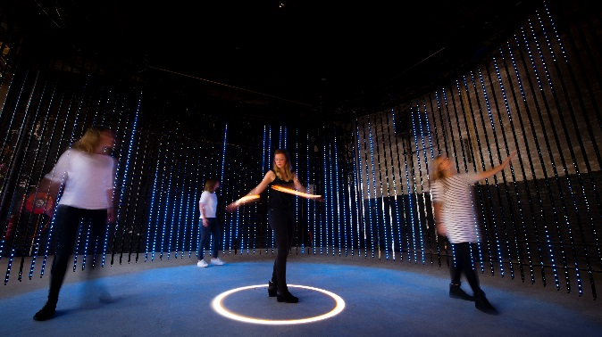
‘’Lightfall’’ is the latest in a series of lighting installations created by Paul Thursfield, Head of Service Design at Philips Lighting Design and Simon Rycroft, Senior Strategic Designer at Philips Lighting that explore generative and interactive light and sound as part of their research into new light experiences. “Lightfall" is a cascade of light triggered by people who dip their hands into the pool of light at the center of the pavilion. The unique light and sound signature is generated based on the parameters programmed by the artist and sensor inputs from people in the pavilion. The pavilion is constructed from a circular curtain of Philips Color Kinetics LED lights, commonly used in commercial projects for shopping centers and city landmarks.

“LED technology allows us to radically rethink the way we construct and interact with architectural lighting. We’re thrilled to exhibit two pieces as part of Dutch Design Week that explore the beautiful possibilities of using light in new and innovative ways,’’ said Pierre-Yves Panis, Head of Design for Philips Lighting.

Both lighting installations are part of the ‘’ESCAPE – embracing the freedom of beauty’’ exhibition at ‘Kazerne’ gallery and creative hub in Eindhoven, and will be on display until February 2017.

###
Notes to editors:
- In October of each year, Dutch Design Week (DDW) takes place in Eindhoven, the Netherlands. The biggest design event in Northern Europe presents work and ideas of more than 2500 designers to more than 275,000 visitors from home and abroad.
- BCXSY is an Amsterdam-based interdisciplinary cooperative between designers Boaz Cohen (Israel, 1978) and Sayaka Yamamoto (Japan, 1984). Established in 2007, BCXSY continues to carry out a wide range of projects, both in The Netherlands and abroad.
- Kazerne is the international platform for the creative industry in the heart of design and technology city Eindhoven, the Netherlands.

For further information, please contact:

Philips Lighting Global
Anne-Marie Sleurink
Tel: +31 6 52 59 63 81
E-mail: anne-marie.sleurink@philips.com

About Philips Lighting
Philips Lighting (Euronext Amsterdam ticker: LIGHT), a global leader in lighting products, systems and services, delivers innovations that unlock business value, providing rich user experiences that help improve lives. Serving professional and consumer markets, we lead the industry in leveraging the Internet of Things to transform homes, buildings and urban spaces. With 2015 sales of EUR 7.5 billion, we have approximately 34,000 employees in over 70 countries. News from Philips Lighting is located at http://www.newsroom.lighting.philips.com

